Test results.   
  
Fig.1 is data vs prediction after optimization end. Both Adam and BFGS were run for 100 iterations each.

Fig. 2 is loss evolution over iteration. Both Adam and BFGS were run for 100 iterations each.

Fig. 3 is from a test run with only ADAM but 3000 iterations.

Note : Depending on system CPU, BFGS can be slower than ADAM

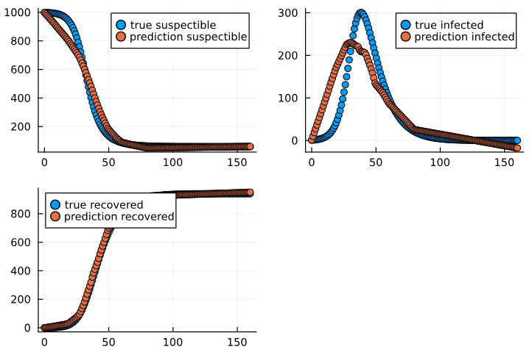It’s better to use ADAM with adequate learning rate and GPU. Or use a combination of ADAM and BFGS on GPU. Use GPU with dedicated high RAM value.

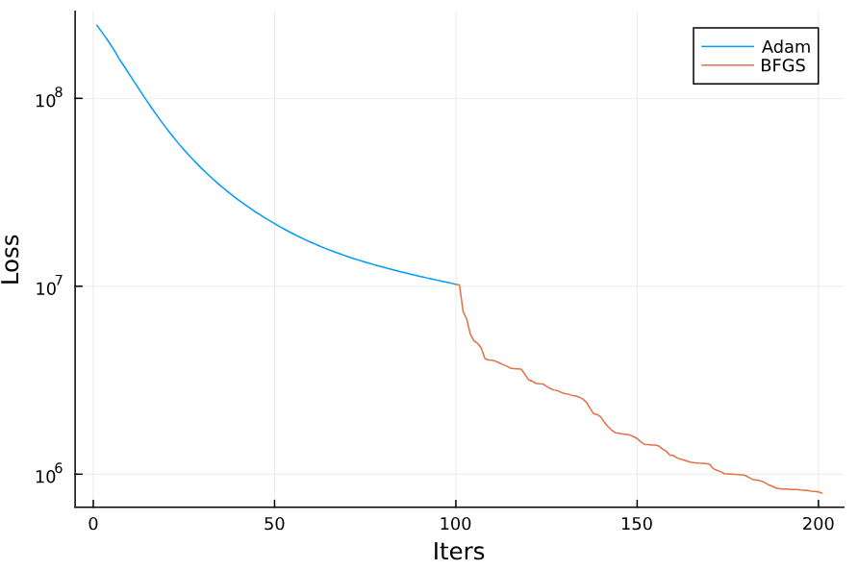**Fig. 1 : Data vs prediction, with 100 iteration each for ADAM followed by BFGS**

**Fig. 2 : Loss vs iteration, BFGS probably converges faster at this time. But each iteration is longer.**

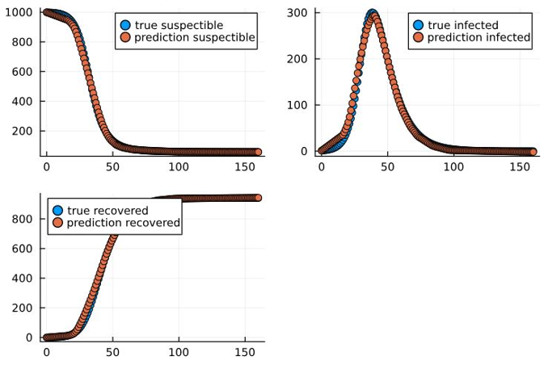**Fig. 3 : Data vs prediction, with 3000 iterations using Adam**